What is AWS IOT Core?

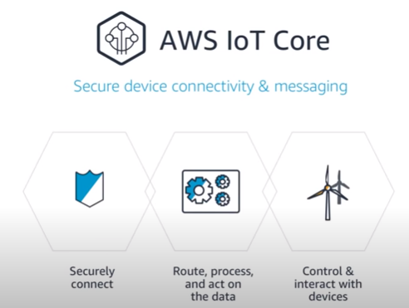

AWS IoT Analytics is **a fully managed service that operationalizes analyses and scales automatically to support up to petabytes of IoT data**. With AWS IoT Analytics, you can analyze data from millions of devices and build fast, responsive IoT applications without managing hardware or infrastructure.

AWS IOT Device Management

To maintain fleet health

AWS IOT Device Defender

AWS IOT Analytics

California Water Service Group Streamlines Field Service and Enterprise Asset Management with KloudGin on AWS

California Water Service improved work order throughput by 25 percent after implementing a field service management and enterprise asset management solution from AWS Partner KloudGin, a member of the AWS ISV Accelerate Program. The water utility, which serves two million customers, needed a mobile work order management solution to improve employee productivity and the customer experience. It worked with KloudGin to develop an AWS-backed solution that addressed the challenges that its field employees experienced. Using AWS services such as Amazon CloudWatch, KloudGin helps Group respond to more customer requests. Group improved work order throughput by 25 percent after implementing a field service management and enterprise asset management solution from AWS Partner KloudGin, a member of the AWS ISV Accelerate Program. The water utility, which serves two million customers, needed a mobile work order management solution to improve employee productivity and the customer experience. It worked with KloudGin to develop an AWS-backed solution that addressed the challenges that its field employees experienced. Using AWS services such as Amazon CloudWatch, KloudGin helps Group respond to more customer requests.

Continuing to Explore Cloud-Native Solutions on AWS

Using the FSM and EAM solution, Group has improved productivity and gained centralized and efficient access to its data and is better equipped to respond to customer requests. Going forward, Group plans to develop more solutions with KloudGin. The two companies are building a tool to prioritize major infrastructure investments, using equipment data to produce a prioritized list of assets for improvement, replacement, and up-sizing.